**Affidavit (Annexure C)**

I Etisha Pednekar, d/o Manoj Pednekar aged 21 years, having my address at

683, Phondaghat(Bazarpeth), Kankavli, Sindhudurg, 416601 hereby solemnly affirm and sincere state as follows:

I hereby confirm that, **M/s. Cognizant Technology Solutions India Private Limited**, herein after referred as “**Cognizant**”, has accepted my request to join their employment in spite of my final year results not being announced by my College / University. I am thankful to Cognizant to consider and accept my request and giving me an opportunity to be part of the prestigious employer.

I understand that the eligibility conditions cited out in the offer letter dated 09/06/2025 shall be enforceable as per the terms mentioned in the offer letter. I agree that, acceptance by Cognizant and permitting to join the employment does not forego any conditions set out in the offer letter.

I hereby state that I am in receipt of an offer letter dated 09/06/2025 based on the representations made by me to Cognizant. In addition to the representations already made by me to Cognizant I hereby represent/acknowledge/agree as follows:

1. I agree that, I shall clear all the exams as part of my B.E in Computer Engineering course completion pursued at Dr. D. Y. Patil Institute of Technology, Pune with an aggregate of 60% and above marks/grade or its equivalent subject to clearing all the exams without Arrears on or before 90 days from my date of joining with Cognizant.

1. I agree that it is my responsibility to contact the Cognizant point of contact to submit all the documents in support of me having cleared all the exams as part of my B.E in Computer Engineering course completion pursued at Dr. D. Y. Patil Institute of Technology, Pune with an aggregate of 60% and above marks/grade or its equivalent as a proof to confirm clearing all the exams without Arrears on or before 90 days from my date of joining with Cognizant.

1. I agree that, in case of failure to produce the documents referred in point b (above), I shall submit a valid proof substantiating my failure to produce the documents and a revised timeline to submit the same with Cognizant. However, Cognizant is at liberty to either accept / deny such request and take necessary actions including suspension and / or termination of my employment with Cognizant.

1. I agree that, Cognizant shall be at liberty to conduct back ground verification or necessary reference checks as it deems fit to ascertain the veracity of the representations made by me to Cognizant.

1. I agree that, Cognizant shall be at liberty to terminate my employment subject to non-adherence of course completion or / and non-adherence to desired pass percentage as called out in Point a (above) and as per the eligibility conditions cited out in the offer letter dated 09/06/2025.

1. I agree that, Cognizant shall terminate my employment subject to non-adherence of all or any one of the below listed, within 90 days from my date of joining with Cognizant ;
   1. Course completion
   2. Eligibility conditions cited out in the offer letter dated 09/06/2025
   3. Desired pass percentage as called out in **Point a** (above)
   4. Failure to submit the proof of course completion as called out in **Point b** (above)

1. I agree that, Cognizant shall terminate my employment agreement or any other document containing the terms and conditions of my employment with Cognizant, upon it being found that any representations or statements made by me to Cognizant are false or untrue, or upon the verification or checks as set out above being unsatisfactory.

I hereby certify that all the statements made in this document are true and are given by me out of my own free will and as a request to Cognizant.

**SIGNATURE:** 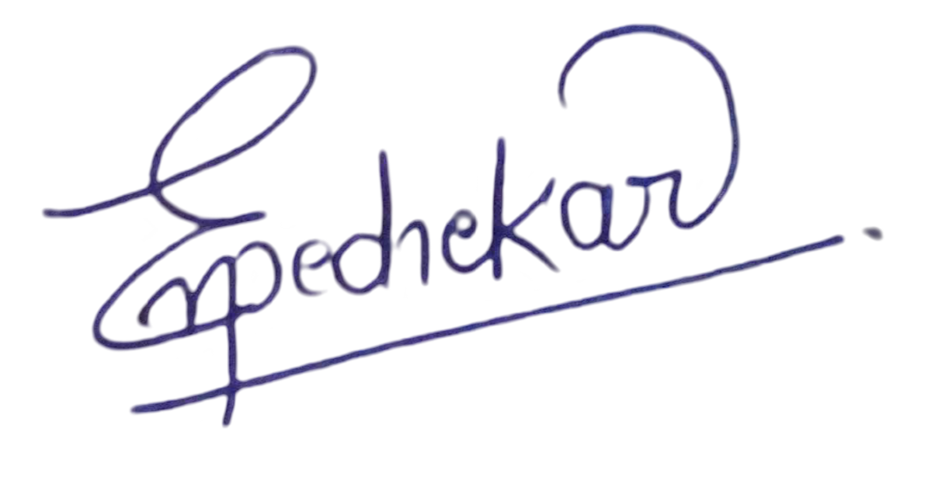

**NAME (IN BLOCK LETTERS): VASANTH NAKKAPOTHULA**